Laravel Lab 2

2)

Create new laravel project lab2q2.

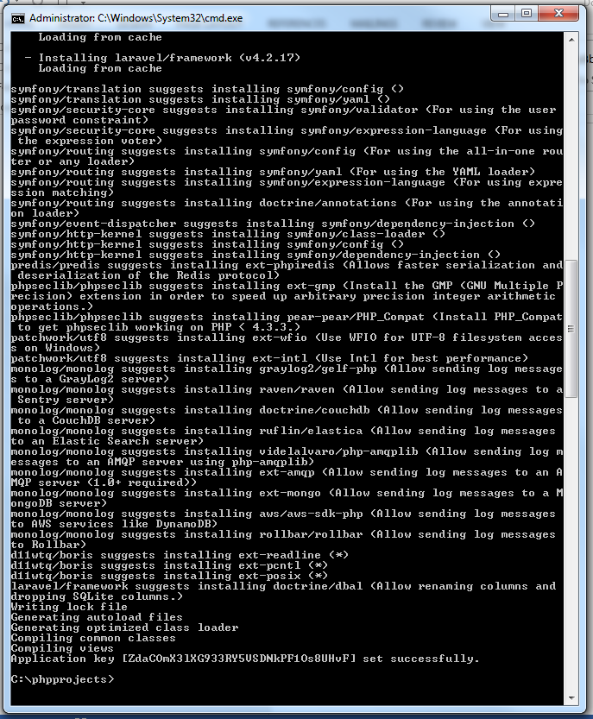

Create routing and view for users and display users message.

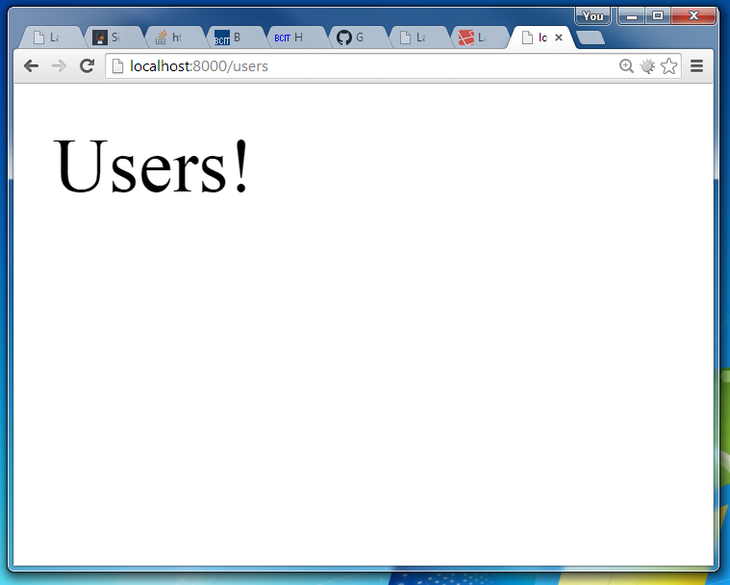

Create a migration for users table data and run.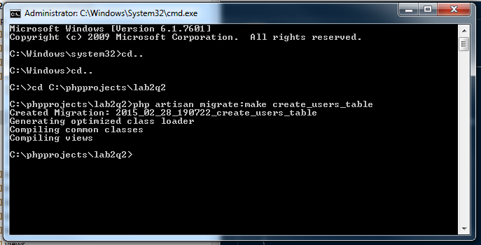

Change routing to call data from users table and send to users view.

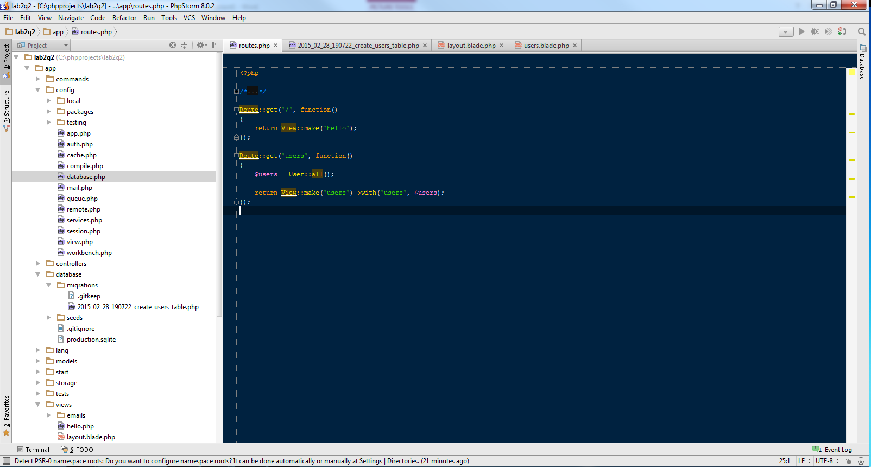

Change view to show all users and run.